**Guideline of Apex interface (ADMIN)**

1. Admin can access the oracle by login with valid username and password.

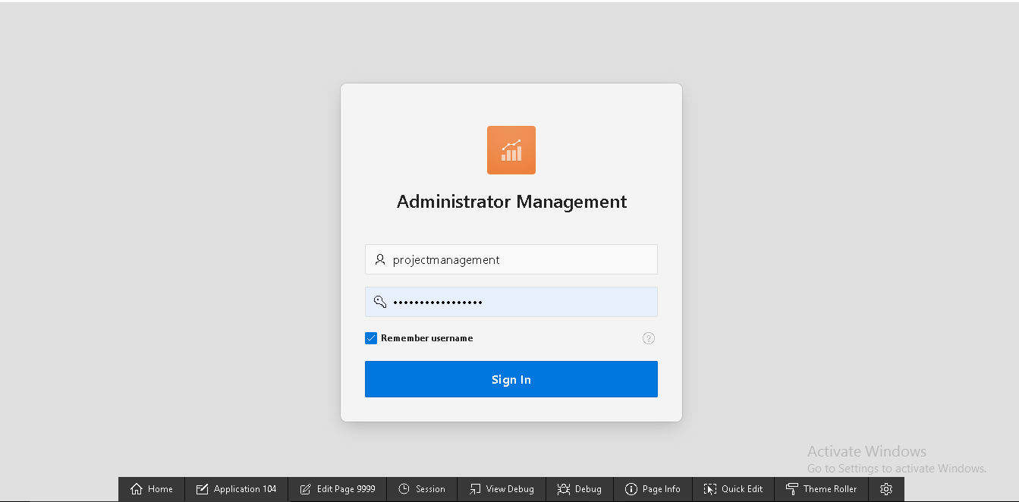

1. After log in, admin will go on the homepage of administrator management where admin can access review details, user details, shop, products, order and dashboard.

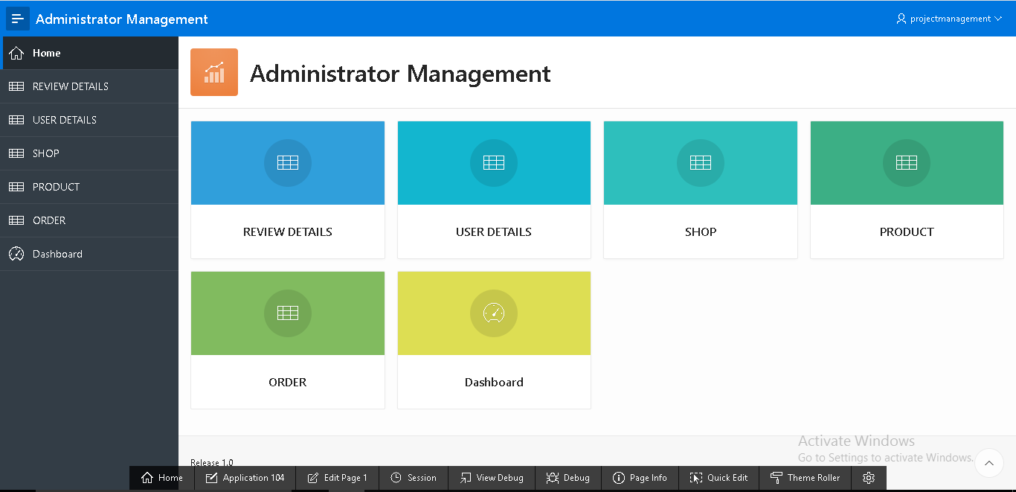

1. Clicking on “Dashboard” tab admin will be able to see the details of bar graph and chart of product max stock and product price.

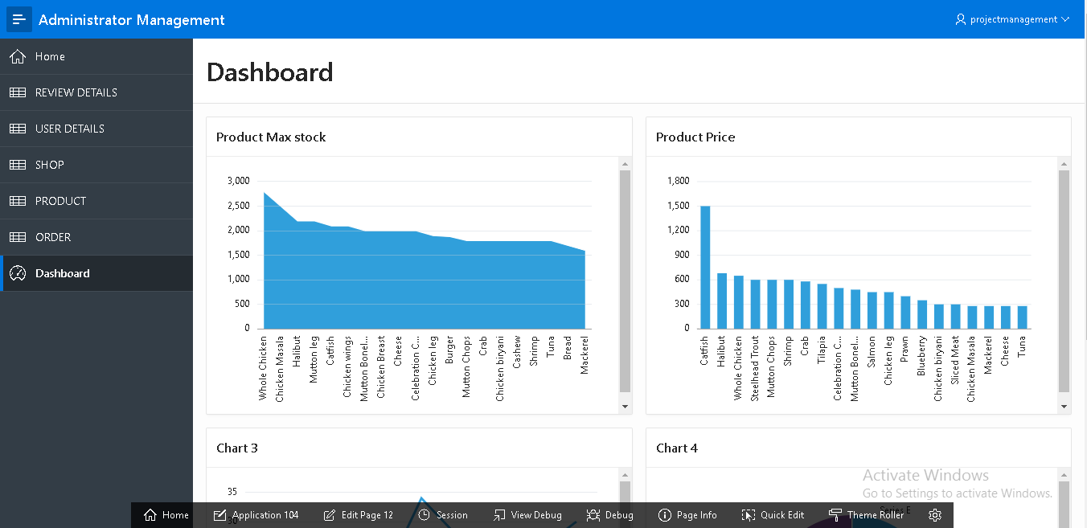

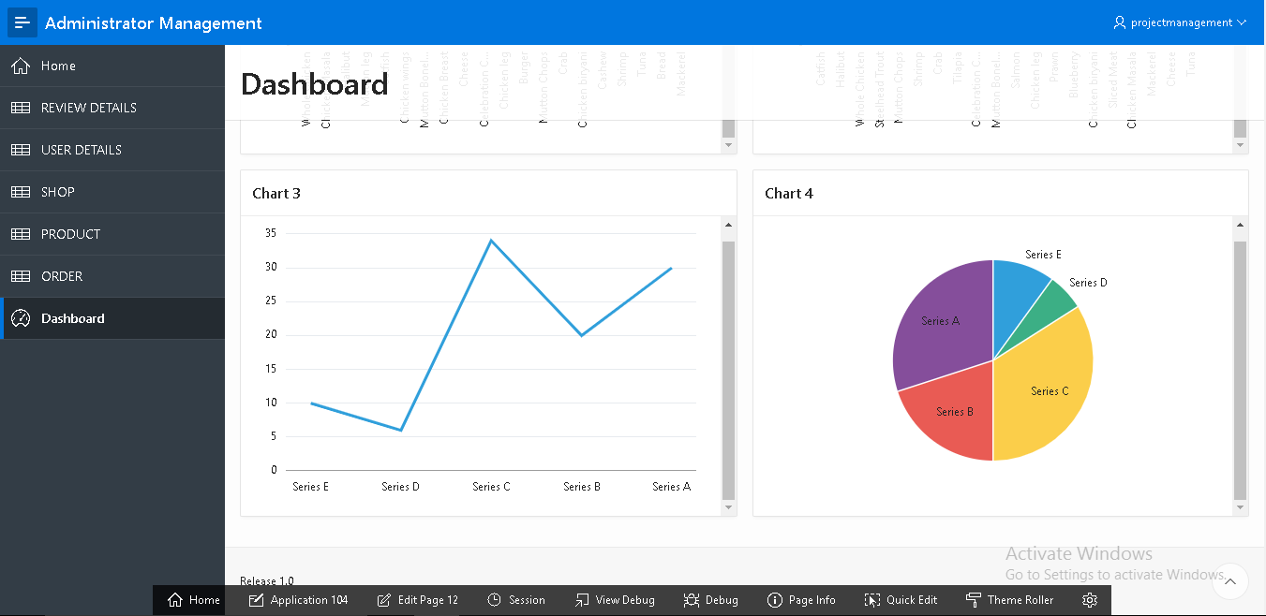

1. Similarly, admin can access details of reviews by clicking on “REVIEW DETAILS” tab.

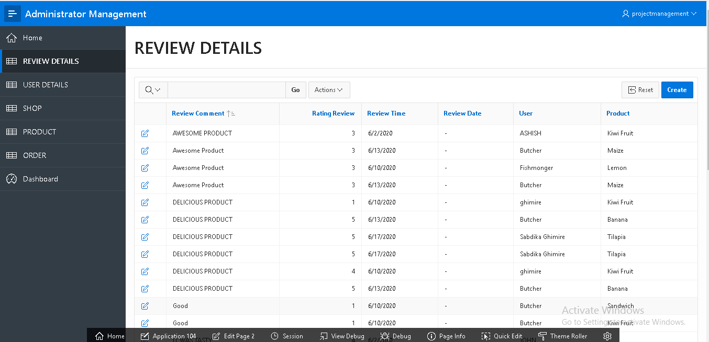

1. On clicking “USER DETAILS” admin can view the detail information of user and user type. Likewise, admin can access data of every tab.

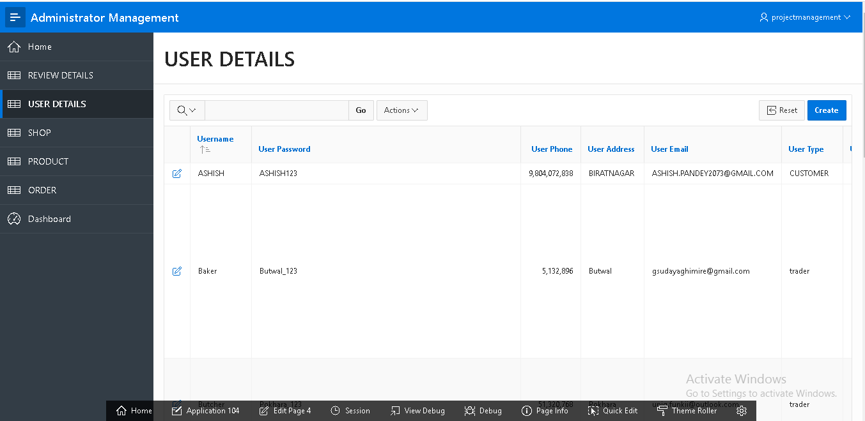

1. Admin have access to insert a shop by going on “SHOP” and filling required field in the form and clicking on “Create” button a new shop will be created.

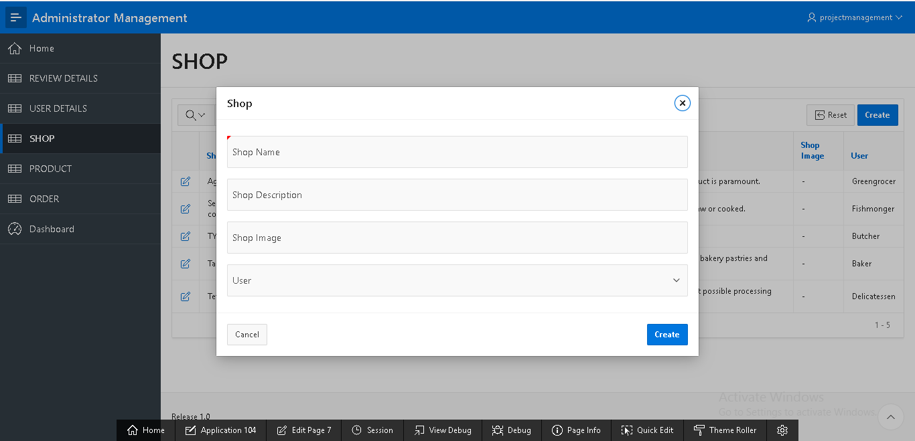

Similarly, admin have access to insert a product, order, user and reviews.

1. Admin can update product and its details by editing any field in the “Product” form. After clicking on “Apply Changes” button product will be updated.

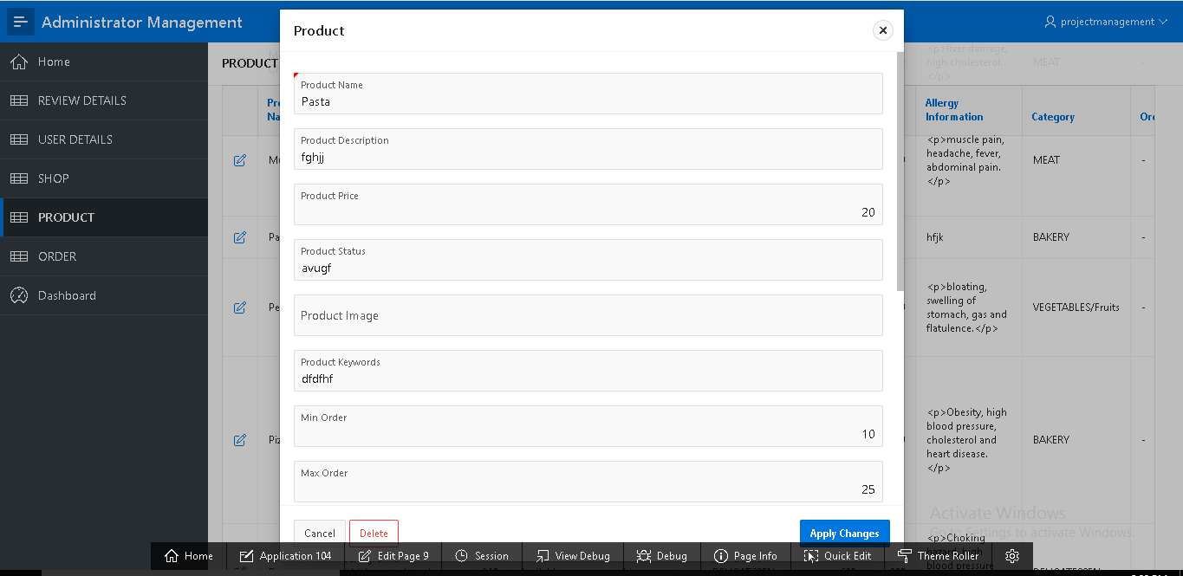

Admin have access to edit reviews details, shop, order and user.

1. Admin can delete specific review details by clicking on “REVIEW DETAILS” tab and opening detail of review and after clicking on “delete” button message will appear and if “OK” button is clicked then review will be deleted.

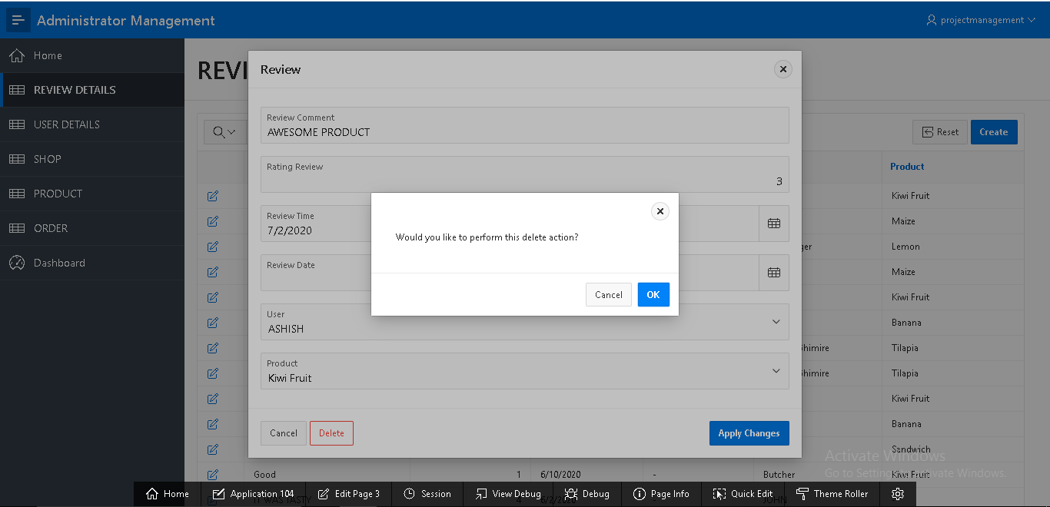

Likewise, admin have authority to perform delete action on user, shop, products and order.

1. In order to sign out admin can click on top right corner in the username a “Sign Out” will pop up after clicking on it admin will sign out from oracle.

